Relocate Source Path

Yesterday, after we had run the last version of the RelocateEnvSrc.bat we observed an ambiguity where

1. The “Error: No source files were rebased” error was thrown and VectorCAST_Coverage_new.bat continued to show the Y:\ drive path.

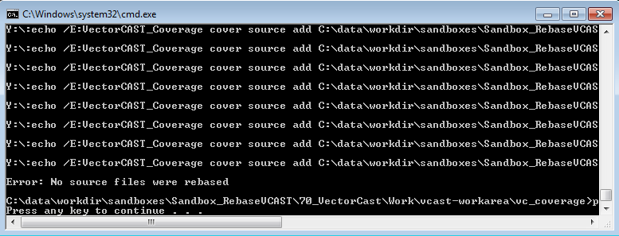

1. However, later we saw that VectorCAST_Coverage_new.bat was indeed updated with the necessary C:\ Drive path and on opening the .vcp file, we also confirmed that the files in the VCAST project we rebased to the C:\ drive path.

As we discussed, to confirm the above points, I have run this batch file on a new Sandbox and following are my observations:

1. After creating the. vcp file with our existing workflow:
   1. We have the .c files mapped to the Y:\ Drive as shown below:

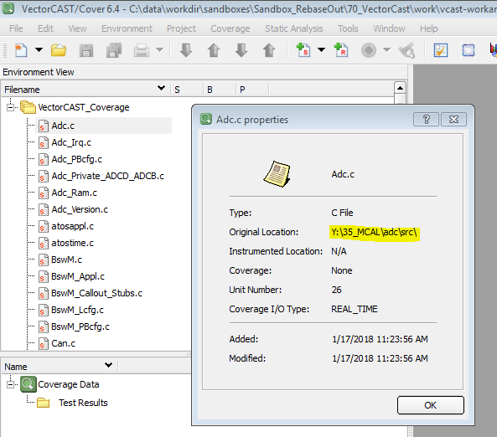

* 1. The contents of \vc_coverage are as below:

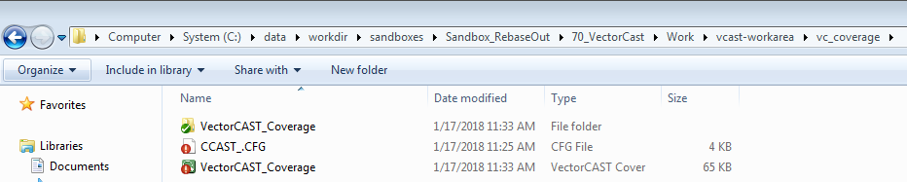

1. After running the RelocateEnvSrc.bat (which creates and runs the VectorCAST_Coverage_new.bat ):
   1. The contents of the \vc_coverage change to

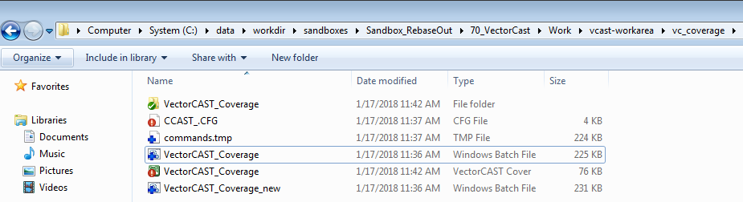

* 1. We now have the .c files mapped to the C:\ Drive

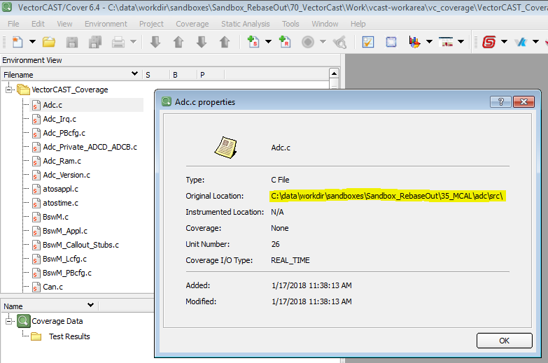

1. On comparing the VectorCAST_Coverage.bat and VectorCAST_Coverage_new.bat, we observed that the relocating has been performed on the .c files and not the .h files as shown below:

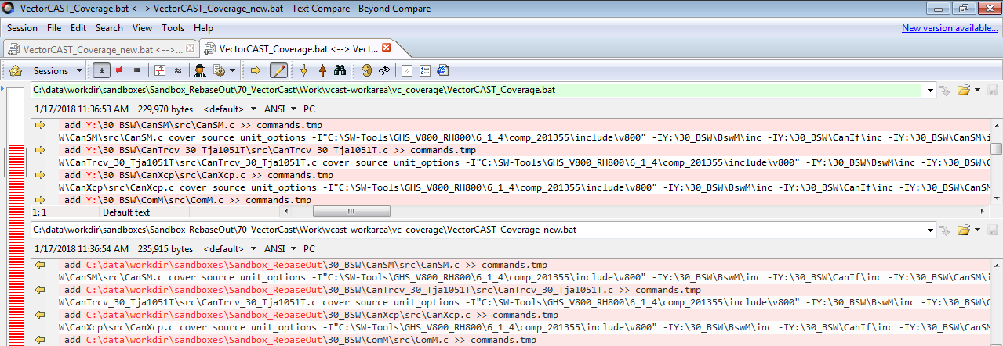

1. As a result of which, when it was attempted to instrument the files in the new. vcp project with relocated source path, following Error was observed:

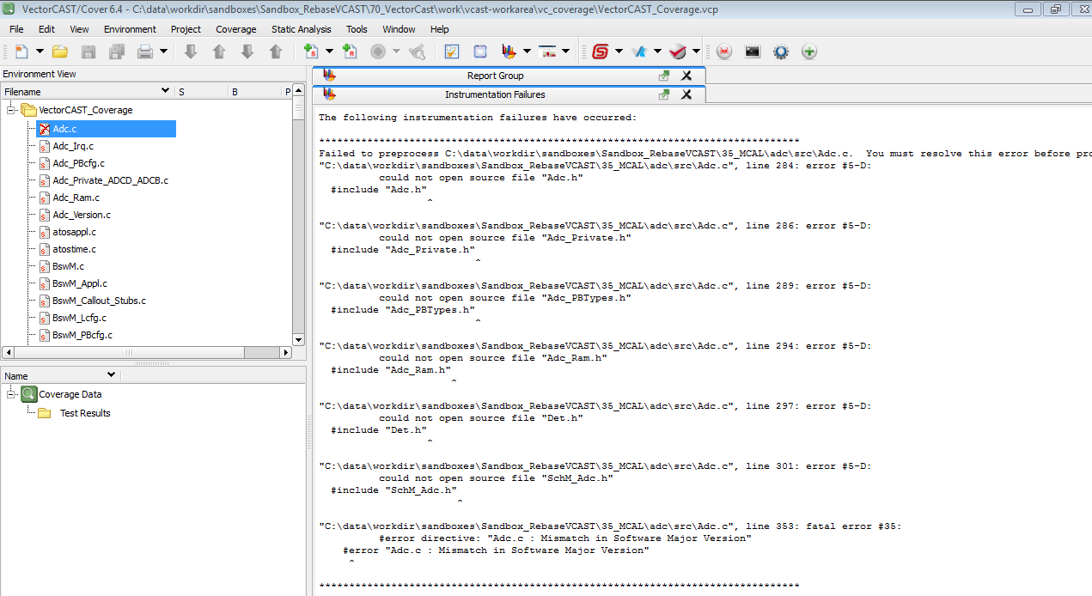

This seems due to the mismatch in the .c file and the .h file paths